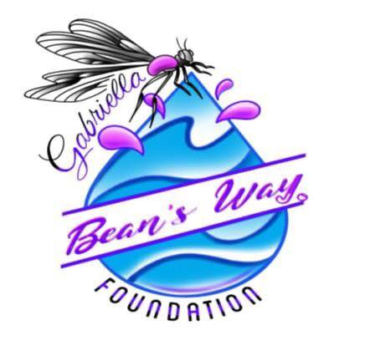
2023 Bean’s Way Foundation
Athletic Scholarship Application
Criteria:

- The nominee must be a female high school senior.
- The nominee must have played a varsity sport for an area high school for at least one full season including their senior year.
- The nominee should demonstrate good scholarship, citizenship, sportsmanship, leadership, and community service.
- The nominee may not be a recipient of a full scholarship whether academic or athletic.
- The nominee should be continuing their sport at the varsity collegiate level.

Name: ____________________________________________________________________

Home address: _____________________________________________________________

Email address: ______________________________________________________________

Parents/Guardians (full names): _________________________________________________

High School: ________________________________________________________________

Name of sport and playing experience: ___________________________________________

___________________________________________________________________________

___________________________________________________________________________
Awards/Recognition: __________________________________________________________

___________________________________________________________________________

___________________________________________________________________________

Service to community and/or sport: _______________________________________________

___________________________________________________________________________

___________________________________________________________________________

College/University you will attend in the fall: ________________________________________

Varsity collegiate sport:
Name of coach:

Include the following and attach with your application:
- Cover letter
- Two (2) letters of recommendation
- Copy of the acceptance letter to the college/university you will attend
- An essay in five hundred (500) words or less answering the following question:
“What role has your sport of choice impacted and help shape your life?”

Return the completed form postmarked before MAY 5, 2023 to:

Beth Keenehan
Chairman, Bean’s Way Scholarship Foundation
110 Kegman Road West
Chesapeake, VA 23322

